**Data Structure LAB #3 Homework**

**[H/W 3-1]**

Make dynamic stack library

**# What is dynamic stack? #**

Dynamic stack means variable capacity stack.

**(Explain)**

If stack capacity is 5 and have 5 items, stack increase capacity to avoid stack full situation.

You can implement dynamic stack below case.

**(Explain – Other case)**

If stack capacity is 5 and have 3 items, stack increase capacity to avoid stack full situation.

You can set Auto increment boundary as you like.

Below images explain stack action of original and dynamic.

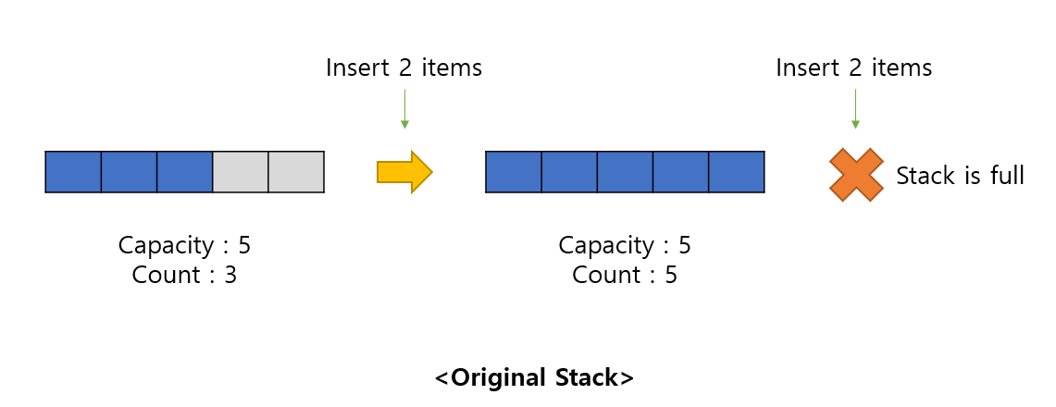

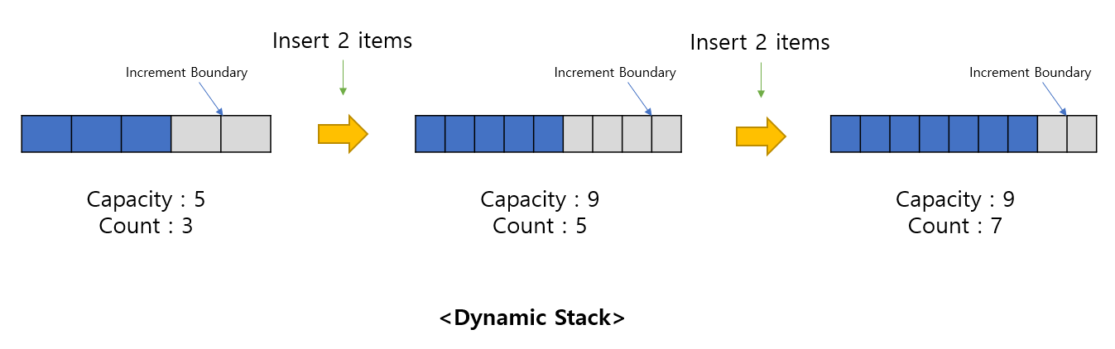

Also, you must keep below cautions.

**<Caution>**

1. Dynamic Stack – Implement **“dstack.h”** & **“dstack.c”**
2. **“dstack.c”** do not contain **‘main’** function. If you implement ‘main’ function in these, your homework will not be graded.
3. You must implement Dynamic Stack by **struct**
4. Dynamic Stack pop and push only **unsigned int**

**<Input>**

None

**<Output>**

Not restricted

Only check that your dynamic stack feature works well.

**[H/W 3-2]**

Implement convert program.

Infix Expression => Postfix Expression

Infix Expression have White Space between number or operator or bracket

Output Postfix Expression with White Space between each element

The range of numbers is the same as the range of unsigned int types.

**(**0 ~ 4,294,967,295)

**Reference your class PDF (Chapter #3 : Stacks and Queues)**

**<Input> - Reference “in.txt” file**

Infix Expression string

**<Output>**

